**Jmeter Assignment**

1. Create Jmeter Scripts of nay sample application show below implimiation in that

Jpetstore is free Java web application for sample Ecommerce application. This example is taken because it has ample correlations and parameterizations

url: https://petstore.octoperf.com/actions/Catalog.action

Task -1

1. Test data should load from external sheet
   1. A test data file is created for searching pet animals in the website. The string identifier is ${searched} stored in file called “C:/Users/HP/Documents/petssearch.csv

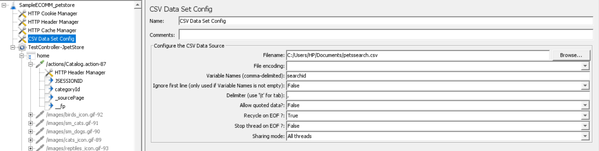

Ii) Show correlation in scripts

1.correlation is achieved for following scripts:

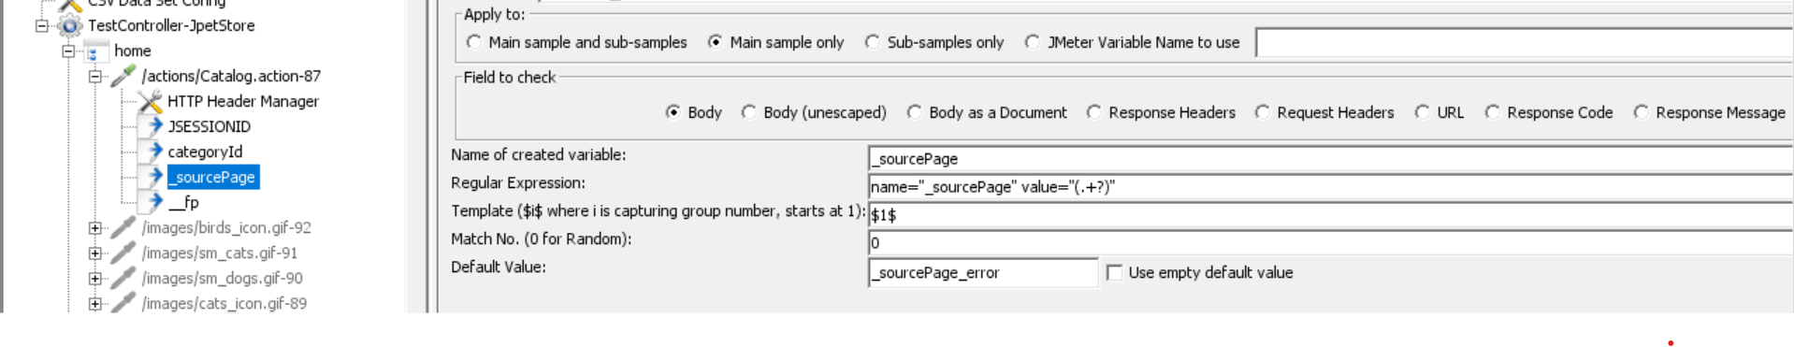

Ii) shoe Parametrization in scripts

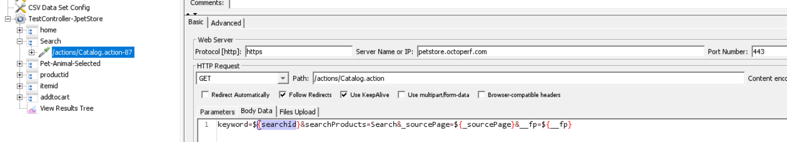

Task -2

1. Put 100 concurrent load in application analysis graph and keep on increasing until you find bottleneck.
2. How many load application can Handel with in 10 min to time span

|  |  |
| --- | --- |
| Transaction / Page Name | Total Transactions |
| name of the api call / page | total number of calls made per api during test |
| home | 46231.00 |
| Search | 46216.00 |
| Pet-Animal-Selected | 46203.00 |
| productid | 46183.00 |
| itemid | 46168.00 |
| addtocart | 46152.00 |
| Total | 277153.00 |
| **Total Users Tested** | **100.00** |
| **Diration** | **10 minutes** |
| **Ramp Up** | **3 minutes** |